**GOVERNMENT POLYTECHNIC DAHOD**

**COMPUTER ENGINEERING**

***5TH SEMESTER***

**PROJECT REPORT**

**GUIDED BY: Pro. Paresh Patel**

**(Lecturer)**

**SUBMITTED BY:**

**Shivani Chauhan (186300307512) Ajab Khanrahim (186300307524)**

|  |  |  |
| --- | --- | --- |
|  | **INDEX** |  |
| **Chapter** | **Title** | **Page No** |
| **1** | **Introduction** |  |
|  | * Summary | 3 |
|  | * Scope | 3 |
|  | * Literature Survey | 4 |
| **2** | **Software/Hardware Requirements** |  |
|  | * Software Requirements | 5 |
|  | * Hardware Requirements | 5 |
|  | * Frontend & Backend | 5 |
| **3** | **System Requirements** |  |
|  | * Requirements of Project | 7 |
|  | * Finalization of Requirements | 7 |
| **4** | **Designing Diagrams** |  |
|  | * Use Cases | 8 |
|  | * ER Diagram | 11 |
|  | * Data Flow Diagram (DFD) | 12 |
|  | * System Flow Diagram | 14 |
|  | * Data Dictionary | 15 |
| **5** | **Conclusion** | 17 |

**1. INTRODUCTION**

* **Summary**

This project is aimed to developing an online Blood Donation Information. The entire project has been developed keeping in view of the distributed client server computing technology, in mind.

The Blood Donation System is to create an e-Information about the donor and organization that are related to donating the blood. Through this application any person who is interested in donating the blood can register himself in the same way if any organization wants to register itself with this site that can also register. More over if any general consumer wants to make request blood online. they can also take the help of this site.

The project has been planned to be having the view of distributed architecture, with centralized storage of the database. The application for the storage of the data has been planned. Using the constructs of MS-SQL Server and all the user interfaces have been designed using the VB.Net technologies.

Admin is the main authority who can do addition, deletion, and modification if required.

The application takes care of different modules and their associated reports, which are produced as per the applicable strategies and standards that are put forwarded by the administrative staff.

The authentication and authorization will cross checked at all the relevant stages. The user level accessibility has been restricted into two zones namely.

* **Scope of Our Project**

The Scope of the project is that in a very short span, it provides user with many facilities. It provides an elegant management of blood, list of hospitals, blood banks and donors online. The main purpose of this project is to interconnect all the blood banks, hospitals, donors into a single network, validation, store various data and information of blood and health of each individual. This system is used to store data over a centralized server which consist of database where the individuals’ information cannot be accessed by a third party.

* **Literature Survey of Our Project**
* Existing system (red cross blood donation)
* Cannot Upload and Download the latest updates.
* Less Security.
* No proper coordination between different Applications and Users.
* Fewer Users – Friendly

**2. HARDWARE & SOFTWARE REQUIREMENTS OF OUR PROJECT**

* **Hardware Requirements:**
* PIV 2.8 GHz Processor and Above
* RAM 512MB and Above
* HDD 20 GB Hard Disk Space and Above
* **Software Requirements:**
* WINDOWS OS (Microsoft Windows 10)
* Visual Studio .Net 2012
* Internet Information Server 5.0 (IIS)
* Visual Studio .Net Framework
* Microsoft Access
* **Frontend & Backend**
* Front End: Microsoft Visual Studio 2012
* Back End: MS Database Access
* Operation System: Microsoft Windows 10

**3. SYSTEM REQUIREMENTS**

* **Requirments Of Our Project**
* Login of Admin
* Blood Donors
* Change the login password of admin
* Register the Donor by himself/herself
* Login of the Donor
* Change the login password of the Donor
* Change the personal contact details by the donor himself
* Change the personal contact details by the system admin
* Withdraw the registration details by donor
* Withdraw the registration details by admin
* Send blood donation details to the relevant donor
* Send blood testing details
* Register organization itself
* Change the login password organization itself
* Contact Support
* **Finalization of Requirements**
* Login of Admin
* Blood Donors
* Change the login password of admin
* Register the Donor by himself/herself
* Login of the Donor
* Change the personal contact details by the system admin
* Withdraw the registration details by admin
* Send blood donation details to the relevant donor
* Register organization itself
* Contact Support

**4.DESINGING DIAGRAMS**

* **Use Case Diagram :-**

Blood Donation Agent Interface



Home Page



Login Page



Donor Home Page



Donor Account Detail



Make Request for Blood



Organization Search Page



Search



Contact Support



About US

**Admin**

**Blood Donation System**

Home Page

Login Page

Donor Home Page

Donor Account Detail

Make Request for Blood

Organization Search Page

Search

Contact Support

Contact Support

About us

About US

**Donor**

Blood Donation System

Home Page

Login Page

Organization Home Page

Donor Search Page

Make Request for Blood

Organization Account Detail

Search

Contact Support

About US

**Organization**

* **Entity Realtion Diagram (ER) :-**

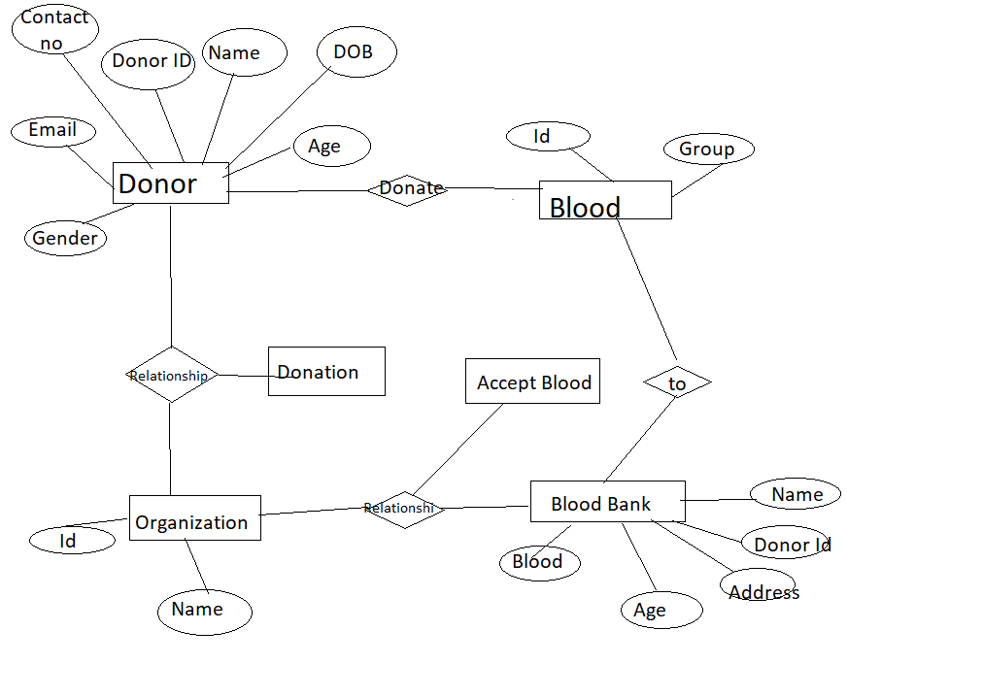

* **Data Flow Diagram :-**

|  |  |  |  |  |
| --- | --- | --- | --- | --- |
| Context level:  **Blood Donors**  Receiving  Donate  Blood  **Organization** |  |  |  |  |

Level 1:

**Blood Donors**

**Emergency**

**About**

**us**

Donor

Registration

Donating

Blood

Donor

Search

**Contact**

**Support**

Receiving

Services

Receiving

Information

Services

login

Level 2:

**Blood Donors**

**Emergency**

**About Us**

Donor

Registration

Donating

Blood

Donor

Search

**Contact**

**Support**

Receiving

Services

Receiving

Information

Services

**Login**

Donor

Not Found

**Receive Donor Details**

Donor Found

Contact donor Not Found

Contact Donor Found

Getting Registered

Searching for Donor

|  |  |  |  |  |  |  |  |  |
| --- | --- | --- | --- | --- | --- | --- | --- | --- |
|  |  |  |  |  |  |  |  |  |
|  |  | | | | | | | |
|  |
|  |
|  |
|  |
|  |
|  |
|  |
|  |
|  |
|  |
|  |
|  |
|  |
|  |
|  |
|  |
|  |

* **System Flow Diagram :-**

Admin

Blood

Donors

Organization

Registration

Check Organization

Contact Organization

Donor

Search

Contacts

Emregency

Services

Contact

Support

General

Information

Blood Group

Inquiry

* **Data Dictionary :-**

**BDS_BloodDonationDetails**

|  |  |  |  |  |
| --- | --- | --- | --- | --- |
| **Sno** | **Column name** | **Datatype** | **Constraint** | **reference** |
| 1 | ID | Int | Primary Key |  |
| 2 | DonorID | Int | Foreign key | BDA_BloodRequest |
| 3 | DonationDate | Datetime | Notnull |  |
| 4 | TakerID | Int | Foreign key | BDA_UserAccount |
| 5 | OrgID | Int | Foreign key | Bda_Organisation |
| 6 | Quantity | varchar(10) | Allow Null |  |

**BDS_BloodGroup**

|  |  |  |  |  |
| --- | --- | --- | --- | --- |
| **Sno** | **Columnname** | **Datatype** | **Constraint** | **reference** |
| 1 | BloodGroupID | Int | Primary Key |  |
| 2 | BloodGroup | varchar(10) | Not Null |  |
| 3 | Description | varchar(1024) | Allow Null |  |

**BDS_BloodType**

|  |  |  |  |  |
| --- | --- | --- | --- | --- |
| **Sno** | **Columnnames** | **Datatypes** | **Constraint** | **reference** |
| 1 | BloodTypeID | Int | Primary Key |  |
| 2 | TypeName | varchar(50) | Not null |  |
| 3 | TypeDesc | varchar(1024) | AllowNull |  |

**BDS_Organisation**

|  |  |  |  |  |
| --- | --- | --- | --- | --- |
| Sno | Columnname | Datatype | Constraint | reference |
| 1 | OrgID | Int | Primary key |  |
| 2 | OrgName | varchar(100) | Not null |  |
| 3 | OrgType | Int | Foreign key | BDA_Organisation Type |
| 4 | Email | varchar(50) | Allownull |  |
| 5 | OrgAddrID | Int | Foreign key | BDA_Address |
| 6 | OrgImageURL | varchar(155) | Allownull |  |
| 7 | OrgDescription | varchar(1024) | Allownull |  |
| 8 | ContactNo | varchar(20) | Allownull |  |
| 9 | MobileNo | varchar(20) | Allownull |  |

**BDS_UserAccount**

|  |  |  |  |  |
| --- | --- | --- | --- | --- |
| **Sno** | **Columnname** | **Datatype** | **Constraint** | **Reference** |
| 1 | AccountID | Int | Primary key |  |
| 2 | Username | varchar(100) | Not null |  |
| 3 | Password | varchar(100) | Not null |  |
| 4 | UserDesc | varchar(1024) | Allow null |  |
| 5 | HintQuestion | varchar(155) | Allow null |  |
| 6 | Answer | varchar(155) | Allow null |  |
| 7 | RoleID | Int | Foreign key | BDA_UserRole |

**5. CONCLUSION**

This project has given us an opportunity to design, code, test and implements an application. This has helped in putting into practice of various Software Engineering principles and Database Management concepts like maintaining integrity and consistency of data.

**THANK YOU**